GETTING TO KNOW THE PARTS OF THE CAMERA

Using the diagrams below label the parts of the camera that you learnt in class.

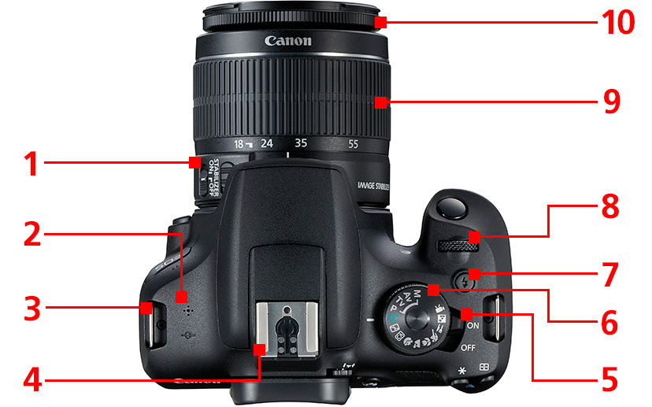

1
2
3
4
5
6
7
8
9
10

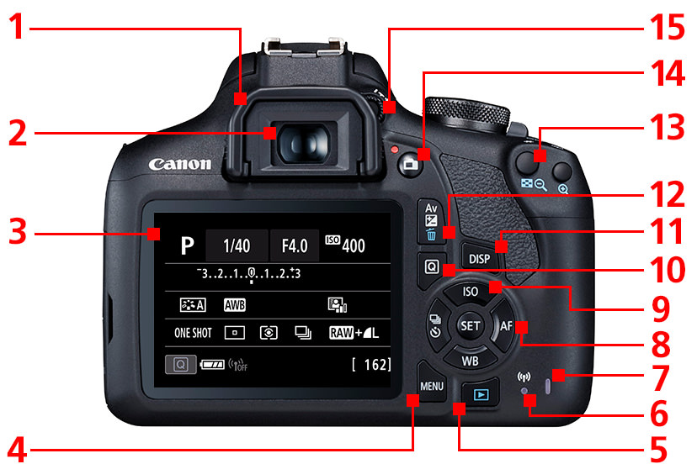

1
2
3
4
5
6
7
8
9
10
11
12
13
14
15

